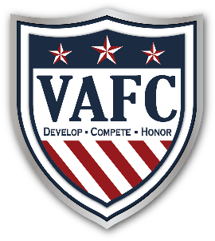
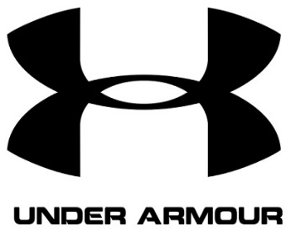
Registration Night Checklist
July 15, 2019

- Pick up the following upon arrival
  - VYSA Medical Release Form ______
  - US Club Soccer Youth Player Registration Form ______
  - Under Armour Uniform Order Form (if needed) ______
  - VAFC Spirit Wear Order Form ______
- Fill out all forms in full ______
- Email headshot w/name to info@vafcyouth.com ______
- Proceed to check out table ______
  - Turn in copy of birth certificate or passport ______
  - Turn in all forms listed above ______
  - Confirm registration status ______
  - Confirm uniform & dues status ______

- Print Player Name ____________________
- Sign & date below to complete registration

Parent/Guardian__________________________ Date________________

www.vafcyouth.com

